Using Explore cards
What is it?
- An in-person activity for groups up to 24 (or 48 if work in pairs).
- 24 cards with different strategies for finding jobs (within and beyond academia). On the front is a job hunting strategy, on the reverse are bullet points that offers tips related to this strategy.
Aims of activity:
- To discuss different methods of finding jobs and surfacing ways to explore options.
- To showcase the variety of methods that can be used to find a job.
- For participants to share their lived experiences of finding jobs.
Time: 15-30-60 minutes
Section 1
1. Give every person a card at random.
2. Ask them to move and find someone they haven’t yet spoken to.
3. Give them 3 minutes to discuss the strategy they have on their card.
Prompt questions (verbal or on slide):
How does this work / not work for you?
Might it work for others?
What other approaches would you prefer?
How likely do you think it is to help you develop your career?
4. Ask them to move again and repeat with someone new.
5. Repeat a total of three times. For 15 minute activity do a full session debrief based on the prompt questions. Plus: Did you discover anything surprising? Did you find something you wouldn’t do has worked for others? How likely are you to use this strategy?
15 minute activity ends here --------------------------------------------------------------------------
Section 2
6. Next ask all participants to create a single line continuum – at one end the strategies least likely to succeed (spoiler – it’s ‘do nothing’!). At the other end the strategies most likely to succeed.
7. Do a moving debrief. Start with the strategies least likely to succeed – ask 2 or 3 people to say why they’ve decided these are unlikely to succeed and ask the group if anyone has had a different experience.
8. Move to mid-ranked strategies and do the same, then finally the top ranked strategies. Do a round up and, if you wish, add in any labour market information you may be aware of about recruitment strategies (e.g. use of recruitment agencies by some large organisations for entry level roles).
30 minute activity ends here---------------------------------------------------------------------------
Section 3
9. To extend this activity you can allow 20 minutes for sections 1 and 2 and then add section 3 for action planning.
10. Ask participants to respond to this question: Based on what we have discussed, your own and others’ experiences what job hunting strategies will you take forward?
11. Depending on your group size you may ask people for a verbal response, log responses using an online tool such as Padlet or Mentimeter, or create a sticky note chart.
60 minute activity ends here--------------------------------------------------------------------------

Feel free to adapt how you use these cards to suit your needs.
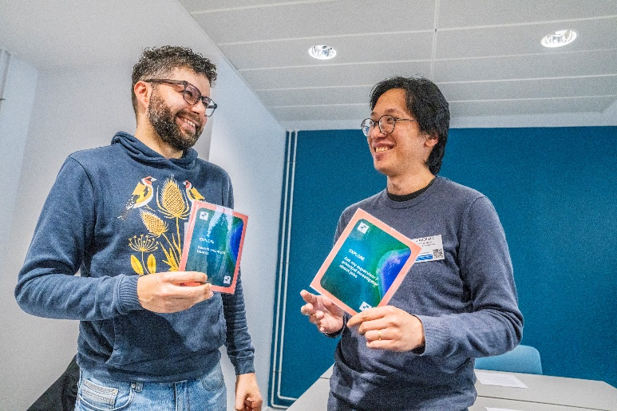
Explore cards in action at the Greater Manchester Research Staff Conference 2026.

