Personal job satisfaction

Start thinking about your own Ikigai

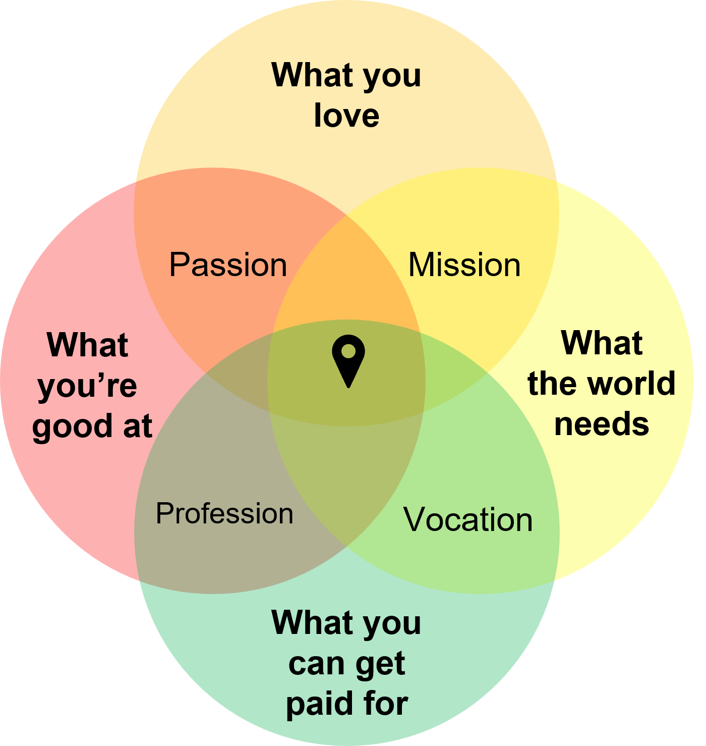
Ikigai is a Japanese concept that refers to a sense of purpose, meaning, and fulfillment in life. The word "ikigai" roughly translates to "a reason for being."

The idea behind ikigai is that everyone has a unique purpose or calling in life and finding and pursuing that purpose can bring a deep sense of satisfaction and contentment. It is believed that ikigai arises from the intersection of four elements:

What you love (your passion)
What you are good at (your profession or skill)
What the world needs (your mission)
What you can be paid for (your vocation or job)
When these four elements come together, it can create a sense of purpose and fulfillment that can enrich one's life.

Read more here https://prosper.liverpool.ac.uk/postdoc-resources/reflect/personal-job-satisfaction/

Start thinking about your own ikigai reflecting on the questions below.
Don’t overthink your answers, bullet points are fine.
There are no right answers, it’s personal to you.

What you love (passion)
Things to consider
- What activities make you lose track of time?
- What do you choose to do when no one is asking or assessing you?
- What kinds of problems do you enjoy thinking about—even when they’re difficult?
- What topics do you naturally read, watch, or talk about outside your research?
- When do you feel most energised during your week?
- If you had a completely free year, how would you spend it?

What the world needs (purpose)
Things to consider
- What problems (big or small) frustrate or concern you?
- Who do you care about helping? (e.g., students, patients, communities, environment, industry)
- What kind of change would you like to see in 10–20 years?
- What gaps or challenges do you notice in your field?
- Where do you feel a sense of responsibility or urgency?
- What do people often come to you for help with?

What you’re good at (strengths)
Things to consider
- What skills have you developed through your PhD or previous work?
- What do others consistently compliment or rely on you for?
- What tasks feel easier for you than for others?
- When have you performed well under pressure, and what strengths did you use?
- What activities give you a sense of achievement or confidence?
- If someone described you at your best, what would they highlight?

What you can get paid for (profession)
Things to consider
- What skills or expertise are currently in demand (in academia or beyond)?
- What roles could you realistically step into today or in the near future?
- What problems do organisations pay people to solve that overlap with your skills/interests?
- Which parts of your current work could translate into a job role?
- What career paths have people with similar backgrounds taken?
- Where could your niche expertise be valuable (e.g., policy, industry, consultancy, education)?

