**Working in the private sector**

The private sector refers to the part of the economy that is not under direct state control (the public sector). Private groups own the organisations or companies often for the establishment of profit but they can also be non-profit entities (also called the third sector and include charities, non-governmental organisations, social enterprises and co-operatives).

The vast majority of universities and other higher education institutions in the UK have charitable status. Most are non-profit organisations. As a postdoc, you may not have worked anywhere other than in higher education. As a result, academic research can often feel removed from profit-driven organisations in the private sector. This can make it hard to envisage a career in this sector.

When you’re considering your career options, it may be tempting to look exclusively at non-profit organisations with a similar culture, ethos or values to academia. Whilst it’s important to align your values with your career decisions, private sector employment can sometimes be too readily dismissed.

**Challenge your assumptions**

As a starting point, ask yourself if any of the following statements resonate with you.

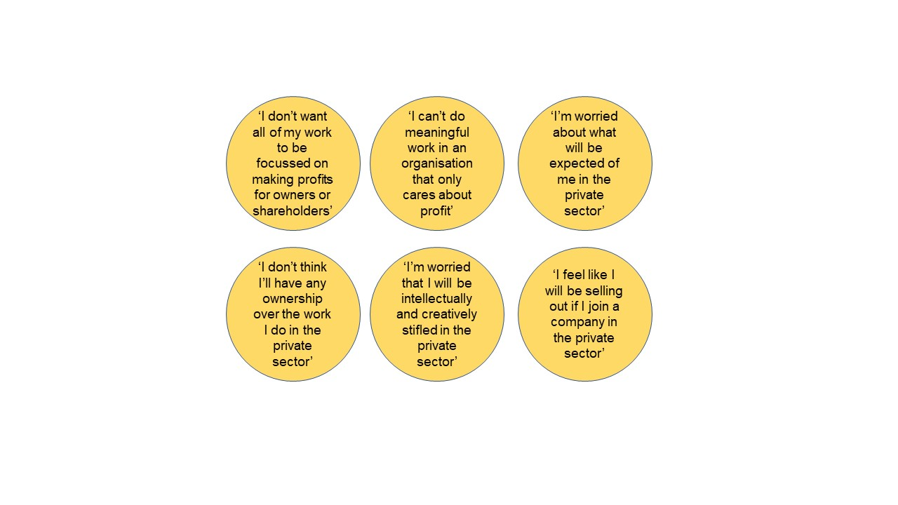

The decision about whether or not to work in the private sector is a personal one. You may have already considered in depth the reasons why it may or may not be suitable for you. However, when making career decisions, it’s important to challenge any assumptions or sweeping judgements that you are making. Many of the statements above might come to mind when considering jobs in the private sector. However, a lot of them may be unfounded once you find out more.

Here, we want to show you that the private sector is not a single entity, it is extremely diverse with many different types of organisations and business models. We also want to show you, using examples, that the boundaries between the private sector, the public sector and the third sector are not so clear cut.

**Academia and the private sector**

A good place to start is by looking at your current role within academia and the academic sector as a whole. It may not seem like it in your everyday life as a postdoc, but there are plenty of overlaps between the goals and activities of universities (and other higher education institutions) and organisations in the private sector. The diagram below gives an overview of some key points to consider.

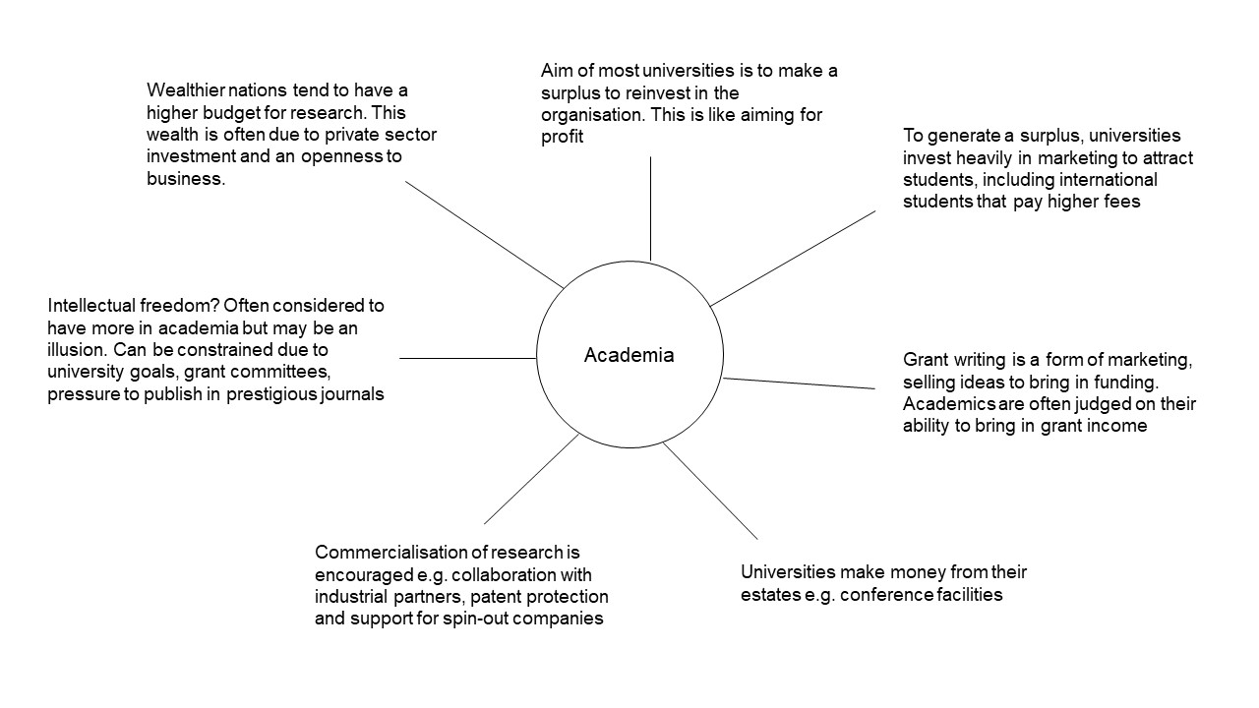

Hopefully the diagram helps you to reflect on academia and its similarities to the private sector. But when we look closely at the private sector, there are many nuances that you should also consider.

**The private sector: making a difference vs. accountability to shareholders**

There isn’t one model, culture or motivation when it comes to the private sector. So, it’s not just about making huge profits. Of course, profitability does come into it for a business to be sustainable and re-invest for the future. But consider the motivation for starting your own venture, which is the root of most private sector organisations. It’s often not solely about making money. People might love what they do and want to continue doing it but this requires financial stability. Or they might want to make a difference, drive change or just be liberated from the hierarchical structures that come with employment.

When considering a career in the private sector, you should also think about the difference between personal and organisational goals. These can be different but co-exist. For example, you could work in a company but in a role that has nothing to do with generating revenue. An example could be in the pharmaceutical industry where companies are sometimes accused of making excess profits. However, the individual research scientists who dedicate their lives to the pursuit of life-saving treatments are often not doing it for the money.

As well as salaries, private companies often give incentives to their employees, which could include private healthcare, career development opportunities or share options. How do you feel about this? Is it ‘wrong’ if these incentives, even if purely financial, provide you with more security and allow you to grow personally and professionally?

When considering your career options, you might have a ‘feeling’ that research in academia is more exciting or fulfilling than in the private sector. This could be the case in some places but perhaps not in others, so it is often better to not prejudge. For example, working in an SME or start-up can have a similar culture to academia but is more directed towards impact. This could actually be more exciting and more aligned with your personal goals. You could join a company to be part of something that is more impactful rather than to make more money.

**The third sector and the public sector: relationship with the private sector**

No one sector of the economy exists in isolation. Working in the public sector or for a values-driven organisation in the third sector may be appealing to postdocs in academia. This is great, if it fits with your personal goals, interests, values and motivations. However, it is important to understand that all organisations must have a funding model to exist and be sustainable. Indeed, there are some prominent examples of charitable organisations that have funding models strongly linked to the private sector.

The [Cystic Fibrosis Foundation](https://www.cff.org/), a non-profit charity in the US, have a business model called [venture philanthropy](https://www.cff.org/about-us/our-venture-philanthropy-model). Many years ago, they invested their funds in an early stage private company (Aurora Biosciences that became [Vertex Pharmaceuticals](https://www.vrtx.com/)) that had promising drug candidates for cystic fibrosis. After several years, they produced a blockbuster drug, making cystic fibrosis a manageable condition for many people. The huge return on investment for the Cystic Fibrosis Foundation could then be re-invested in more treatment strategies. This is an example of a charity funding a for-profit company, with both entities having a mission to eradicate a debilitating disease.

The [Wellcome Trust](https://wellcome.org/) is another large charity that has links, and indeed [origins](https://wellcome.org/who-we-are/history-wellcome), in the private sector. It is one of the largest funders of medical research in the world. It is a non-profit foundation but originated from a for-profit pharmaceutical company – Burroughs Wellcome & Co., which later became GlaxoSmithKline. The Trust was established upon the death of Sir. Henry Wellcome, an entrepreneur and philanthropist. The fortune accumulated by Henry Wellcome through business allowed the formation of a foundation that does undoubted good. In addition, the huge endowment of the Wellcome Trust continues to [invest](https://wellcome.org/who-we-are/investments) in many different areas including private equity, stocks and real estate in order to be sustainable in the long term.

Smaller charities also regularly interact with companies in the private sector. For example, mental health charities such as [Mind](https://www.mind.org.uk/workplace/mind-training/) can be commissioned by organisations to run training events. Many charities also invest heavily in marketing. An example is [Medecins Sans Frontieres](https://msf.org.uk/) who raise much more money than they [spend on fundraising](https://msf.org.uk/how-we-spend-your-money), which indicates that they adopt many of the tactics commonly associated with the private sector.

When you look at the public sector, although ultimately run by the government and for the public good, interaction with the private sector is fundamental to its existence. This could be for operations such as dealing with stationery suppliers or hiring management consultants. On the other side, government schemes are often put in place to encourage private investment and growth of economic activity that is reliant on the private sector.

**Summary**

The aim of this piece was not to push you in any particular direction, but just to get you to think about all of your career options, including those in the private sector. By challenging your assumptions and appreciating that all sectors are interlinked you could expand the number of opportunities available to you.