Prosper evaluation framework
An overview of our initial evaluation framework and how we planned to evaluate each phase of the project

Introducing the framework

Prosper’s evaluation framework sets out a plan for how to monitor the project’s added value to its stakeholders across time, without missing out how the project will be adapted, as the co-creation process evolves. This means that the evaluation process will be iterative, continuously informed by the co-creation with our partners and the relevant feedback we receive, to ensure that the project’s provisions are under continuous improvement and development to meet our audiences’ needs.

Feedback will be collected at multiple times and through various ways, as we view evaluation as an ongoing process embedded in the project rather than an add-on. Both content development and evaluation will be informed by this feedback at multiple stages (Chesniak et al., 2019), ensuring alignment of our partner’s needs to the project’s success targets.

The danger of relying on a single source of evidence to draw conclusions about project value has been consistently highlighted by relevant literature (Bromley and Metcalf, 2012; Walsh et al., 2010). The evaluation of the impact of previous career development initiatives has often been based either purely on reactionary feedback provided via ‘happy sheets’ straight after an intervention had taken place (Cooper and Juniper, 2002) or had largely relied on qualitative data (Faupel-Badger et
al., 2015).

However, following the most recent paradigm of evaluation processes adopted by other postdoctoral career development projects (Lenzi et al., 2020), Prosper’s evaluation framework seeks to collect both qualitative and quantitative evidence at various time points. Our decision to follow this approach has been driven by our strong belief that different types of data serve different purposes and thus are equally important in establishing a robust dataset, whilst also allowing a deeper understanding from the perspective of the participants themselves to emerge.

As illustrated below, Prosper will develop, test and refine resources in a cyclical process of co-creation and iterative evaluation.

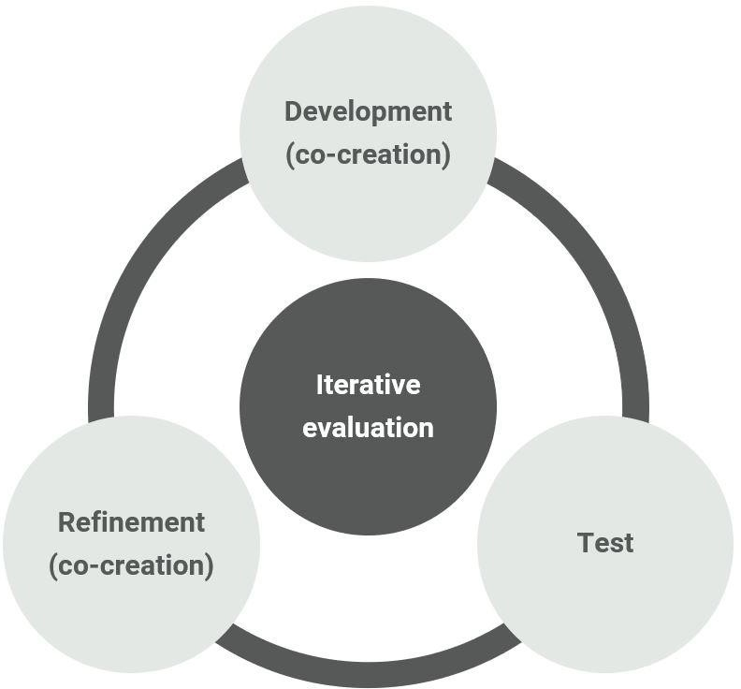

Phase 1
Foundation evaluation+
- Secondary datasets (HESA, HR, CROS/PIRLS etc.)
- Environmental scanning of postdoc development provisions
- Focus group discussions with UoL postdocs and PIs on best practices for postdoc career development, relevant challenges and suggestions for Prosper support needed

Pre-phase 1 evaluation+
- Resources Trials with subgroups of UoL postdocs (Feedback Online Surveys)
- Consultation on resources development with SEP

- Benchmarking survey build-up for SEP Signees (e.g. PI Network)
- In-depth interviews with employers’ subsample
- Pre-Prosper engagement online survey (SKIPI-based) on postdocs’ career development attitudes, skills & practices

Phase 1 evaluation +
- Post-portal engagement survey (Reaction)
- Follow-up online survey (2 months after portal launch)
- Portal embedded feedback forms
- Portal analytics (portal hits, resources’ visits, pathways of navigation, time spent on portal etc.)

Phase 1 summative evaluation and preparation for phase 2+
- Phase 1 summative evaluation (including number and variety of activities offered, groups engaged etc.)
- Focus groups/interviews with subsample of stakeholders covering range of backgrounds (both PIs and postdocs)

Making use of the evidence and data we will have collected by the end of Phase I, we will reflect and tailor our further evaluation process based on lessons learnt so far. Relevant adjustments will be made to evaluation tools that will continue to be used in Phase II along with the creation of new ones to monitor the progression of the Phase II-specific cohort approach. The initial planning for our Phase II evaluation steps are summarised below:

Phase 2
Foundation evaluation+

• Phase I summative evaluation findings
- Career Clusters content co-creation
• Creation of curated database with background characteristics of career clusters’ cohort

Phase 2 pilot of career clusters evaluation+
- Pre-engagement survey (postdocs, PIs & employers)
- Consultation with SEP on resources development
- Monitoring of engagement with development initiatives
- Reflective diary entries/career cluster network meetings to capture cohort participants’ experience on the go

Phase 2 relaunch of portal evaluation+
- Pre-portal engagement online survey (SKIPI-based)
- Post-portal engagement survey (Reaction)
- Follow-up online survey/focus groups with subgroups
- Portal embedded feedback forms
- Portal analytics (hits, resources visits, pathways of navigation, time spent on portal, resources likes/dislikes, gender, faculty, status -postdoc/PI/employer- etc.)

Phase 2 summative evaluation+
- Postdocs Post-Prosper engagement online survey (This survey will focus on data collection around the project’s overall usefulness and participants’ satisfaction. This survey will be turned into a biannual tracking survey, with the addition of sections exploring postdocs’ employment destinations and job satisfaction).
- Employer Post-Prosper engagement survey.
- PI Post-Prosper engagement survey.

• Interviews/focus groups with subsample of survey respondents of various career clusters and stakeholder background.
• Protocol in place for tracking long-term practice change in postdoc development
funding, employer recruitment practices etc.

As evaluation is a dynamic process serving a dual purpose -monitoring what we learn, but also how we learn best- this evaluation framework is an initial plan, that could change as a result of co-creation and/or feedback. So, keep an eye out for updates on the content of this page, as Prosper progresses, in our attempt to highlight some of the opportunities and challenges occurring, while collecting evidence to demonstrate Prosper’s short-term and long-term outcomes.

References
Bromley, T. and Metcalf, J. (2012) The Rugby Impact Framework 2012. Revisiting the Rugby Team Impact Framework. Available at: https://www.vitae.ac.uk/vitae- publications/reports/ieg-report-2012.pdf (Accessed: 19 May 2020).
Chesniak, O. et al. (2019) Creating the Postdoc Academy: A Digital Professional Development Program for Postdocs. Available
at: https://www.postdocacademy.org/files/2019/11/POD-Network-Meeting- Poster_Chesniak.pdf (Accessed: 19 May 2020).
Cooper, G. and Juniper, S. (2002) ‘A Postgraduate Research Training Programme in Generic Skills and Strategies: Description and Evaluation’, in Goody, A., Herrington, J. and Northcote, M. (ed.) Proceedings of the 2002 Annual International Conference of the Higher Education Research and Development Society of Australasia (HERDSA). Perth: HERDSA, pp. 136–143.
Faupel-Badger, J.M. et al. (2015) ‘Alumni Perspectives on Career Preparation during a Postdoctoral Training Program: A Qualitative Study’, CBE- Life Sciences Education, 14, pp.1–8.
Lenzi, R.N. et al. (2020) ‘The NIH “BEST” programs: Institutional Programs, The Program Evaluation, and Early Data’, The FASEB Journal, 34(3), 3570–3582.
Walsh, E., et al. (2010) ‘Evaluation of a Programme of Transferable Skills Development within the PhD: Views of Late Stage Students’, International Journal for Researcher Development, 1(3), pp. 223–247.

