**Decoding job descriptions**

When you first open a job advert and look at the job description (including the essential and desirable criteria) it can be a bit overwhelming, especially if jargon that is unfamiliar to you is used in the text. You can take a methodical approach to tackling job descriptions, by learning how to unpack key phrases into the types of skills being asked for. Then you can think of examples in your own career (or elsewhere) where you have used these skills. It is also an opportunity to reveal any skills gaps or highlight particular skills that you would like to develop further. This exercise shows the ‘real world’ importance of identifying and articulating transferable skills. It is also a useful first step towards tailoring your CV (and perhaps your LinkedIn profile) to the actual job you are applying for. It may also be a quick way of reminding yourself how you match up to the job description prior to an interview.

**Strategy**

* Start by identifying a job advert that you have some interest in. If you’re just practicing, it doesn’t need to be the perfect job or one you’ll actually apply for.
* Scan the job description, including essential and desirable skills/criteria. Sometimes you may find sections called core skills, key responsibilities, ‘what we are looking for’ or ‘your professional experience’ (or variations of these). Pick out key phrases where the employer is asking what they require in the person that they are looking to hire. Write these down.
* Create a diagram or table with the key phrase at the top (if a table) or in the centre (if a diagram) and then two columns (or sections) with the ‘Skills’ being asked for and ‘Examples’ of where you have demonstrated these skills.

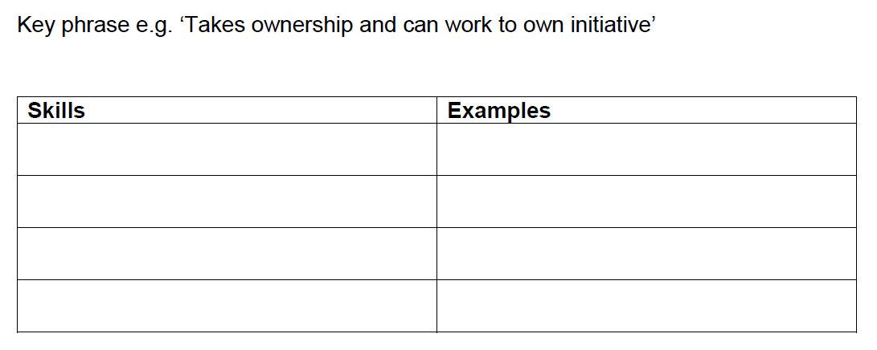

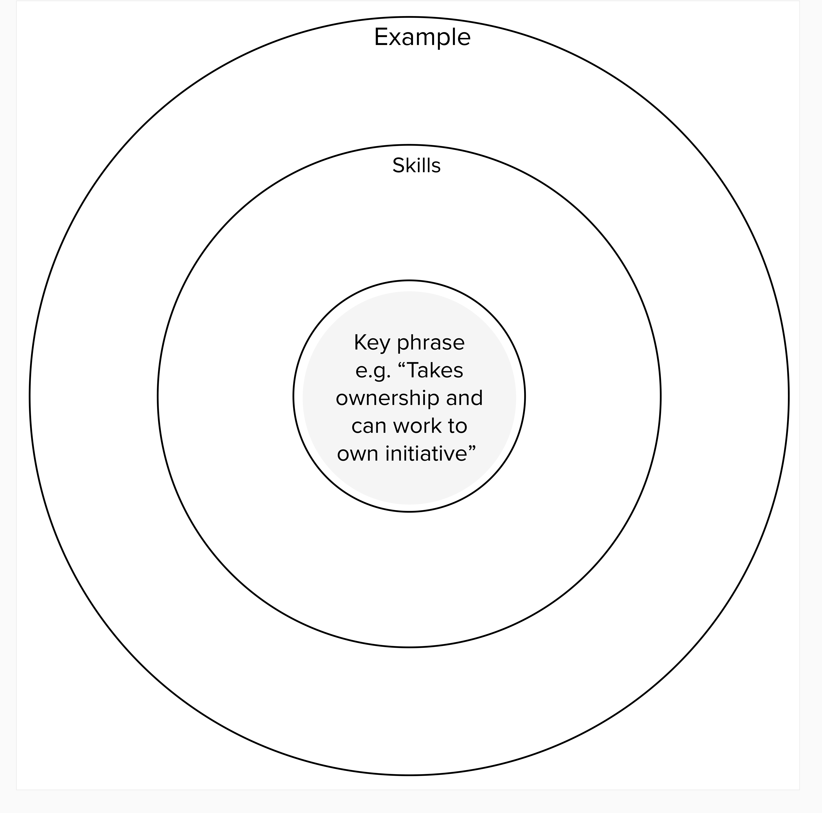

**Worked example with input from actual postdocs**

Planning lead, Driver and Vehicle Licensing Agency (job advert from August 2020)

Key phrase: “You will have experience seeking and analysing information to inform decisions providing advice to a variety of stakeholders, where your exceptional stakeholder engagement and relationship building skills will enable you to influence and challenge at all levels”

|  |  |
| --- | --- |
| **Skills** | **Examples** |
| Information gathering | Using information resources for research. |
| Having difficult conversations | Conversations with manager about contract extensions.  Meetings with PhD students who are not making sufficient progress.  Practice placement: speaking with patients. |
| Advising | PhD/MSc supervision |
| Influencing and persuading | Ran review and revamp of student communications policies and practices.  Convinced manager to allow project to create GCSE resources. |
| Building relationships | Working with web and design agencies.  Working with other departments. |
| Tailoring information for different audiences | Giving public lectures.  Working as a Water sports instructor. |
| Data Analysis | Scientific data processing and analysis. |
| Working with people at all levels | Volunteering at the University graduation ceremonies.  Dealing with student/staff library enquiries |
| Stakeholder engagement | Ran a continuing professional development day for school teachers.  Supervising a work placement module. |
| Communicating | Lecturing.  Writing/presenting at conferences. |

**Task**

Identify a job advert in an area of interest to you. Find a phrase in the job description that stands out and practice this approach of unpacking skills and giving examples from your own career, using either a table or diagram, as above.