PI Workbook to accompany:
Cultural Identity and assessing your current level of Intercultural Competence

Welcome to this workbook which is designed to assist Principal Investigators in recognising your own cultural identity and help you to identify your current level of Intercultural Competence. It is anticipated that engaging with both of these activities will enable you to thrive more effectively in multicultural work settings.

Learning Outcomes

As a result of engaging in the accompanying video recording and using this Workbook it is anticipated that you will:

- Raise self-awareness of personal cultural identity and intercultural preferences to build stronger relationships in multicultural work settings

- Learn how to assess your current level of Intercultural Competence

- Identify your intercultural strengths and development areas to be addressed in future

Agenda

- Personal Cultural Identities
- Self-Assessment of current level of Intercultural Competence
- External assessment of current level of Intercultural Competence
- Your intercultural strengths and development areas

Definition of Intercultural Competence

For greater detail about the definition of culture, multicultural work settings and Intercultural Competence please refer to the video and accompanying workbook entitled “Intercultural Competence and how it can help you thrive in Multicultural Work Settings.” As a reminder Intercultural Competence is described by Deardorff (2009) as:

“The knowledge, skills and attitudes that are required to get along effectively with an individual or a team with a different cultural identity to you.”

Intercultural competence is the measure of your effectiveness when interacting with others who do not share the same cultural background as you.

Raising Cultural Self-Awareness

To work effectively with multicultural colleagues it can be helpful initially to be conscious of your own cultural make-up. Equipped with these insights, it will potentially be easier to recognise areas of cultural common ground as well as differences between yourself and others.

Personal Cultural Identities

Cultural identity is described by Holliday (1999) as “the collection of our multiple identities”. These identities derive from the numerous “social groupings” we are part of, including those related to our nationality, gender, age, sexual orientation, family position, religion, hobbies, occupation, political ties, and education.

EXERCISE: Complete the blank Culture Flower outline below, by adding one of your multiple identities per petal (for example, Son / French / Cricket player / Muslim / Only child / University educated). The purpose of the exercise is to raise awareness of your own cultural complexity and the output can be shared with new colleagues and researchers in order to build trust and seek out greater common ground together. This is a useful ice-breaker type exercise you could introduce at the start of a team meeting.

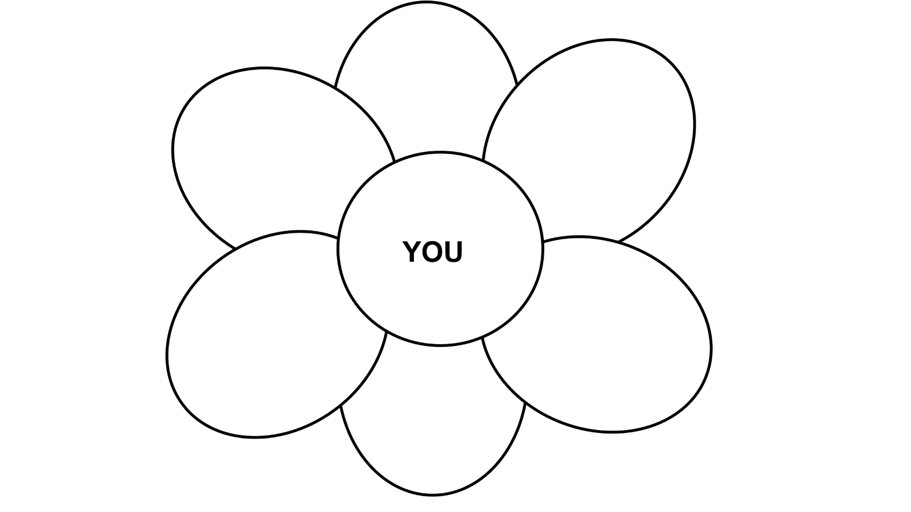
Culture Wise (2015)

Self-Assessment of your current level of Intercultural Competence

It can be helpful initially to establish your current level of Intercultural Competence. We can find out whether you are curious and open to differences, show respect and empathy towards others and suspend beliefs, assumptions, and judgements wherever possible. The skills of listening, observing, and evaluating, interpreting and relationship building are facets of intercultural competence. Intercultural competence incorporates the knowledge gained from cultural self-awareness, from knowing the local cultural context and from having foreign language (where appropriate) and sociolinguistic skills.

Carry out this self-assessment exercise to gain a sense of your current level of intercultural competence and identify gaps that you may wish to focus on in future.

EXERCISE: To recognise the level to which you currently exhibit respect for others, demonstrate openness and display curiosity and empathy, which are all key attributes of intercultural competence as was highlighted earlier in this Workbook, ask yourself the following questions:
- How do I demonstrate that I value those from other cultural backgrounds, even if I disagree with their beliefs and opinions?
- Do I check and verify understanding rather than assuming?
- How willing am I to learn about other cultures?
- Which verbal and non-verbal behaviours make me feel uncomfortable?
- How developed are my language skills?
Use external resources to assess your current level of intercultural competence as well.
External Assessment of your current level of Intercultural Competence
In addition to the self-assessment work outlined above you can also use external resources to deepen your understanding of your own current level of Intercultural Competence.
EXERCISE: Complete the assessment tools available via the Prosper website if you have not done so already.
In addition you might choose to invest in the Intercultural Readiness Check (IRC) profile tool with a personalised hour of debrief and coaching available via an external consultant, Alexandra Beaulieu. Please refer to the Resources list at the end of the Workbook for more details.
Finally you might choose to seek feedback from others whose opinions you trust and respect. Often, peers, researchers, managers and other knowledgeable others can help to identify your intercultural “blind spots” which may be talents and strengths that you do not recognise in yourself or potential areas for development in future.
EXERCISE: Send five to ten individuals an email requesting that they rate you from 1-5 (where 5 is fully exhibiting this skill) on the following aspects of Intercultural Competence and encourage them to include examples of real-life situations:

Skill | Rating (1-5) where 5 is highest | Example
Attentive listening
Suspending judgement
Evaluating options
Relating to others, showing curiosity and empathy
Language skills
Armed with all of this information about your current level of intercultural competence, which combines your own self-reflection with the feedback of others, you now have your baseline. You hopefully know more about your cultural self and the ways that you currently interact with people from different cultural groupings.
EXERCISE: Establish what you can learn from all of this information. Ask yourself the following questions:
- What are my intercultural strengths?
- What are my development areas either in terms of my intercultural attitudes and/or my intercultural skills?

Summary of Learning Outcomes

Having listened to the accompanying video recording and completed this workbook, it is anticipated that you now have:

- An awareness of your personal cultural identities enabling you to build stronger multicultural relationships in future
- Know how to assess your current level of Intercultural Competence and can identity your intercultural strengths and areas for development

Further Information

Please use the details below to contact the creator of this workbook, Sally Walker, Career and Intercultural Coach and Director of SW Career Coaching Limited if you have additional questions or would like to independently arrange 1:1 coaching sessions. These aim to develop your skills as a team leader in a multicultural work environment.

sally@swcareercoaching.com
www.swcareercoaching.com
https://www.linkedin.com/in/sallyannwalker/

Additional Resources

Brown, B (2010) The Power of Vulnerability TED talk:
https://www.ted.com/talks/brene_brown_the_power_of_vulnerability?language=en

Caligiuri, P (2021) Build your cultural agility, London and New York: Kogan Page Limited

Cruse Project Cross Cultural Skills Europe (2022) https://cruseproject.com/learning-resources/

Gibson, R (2021) Bridge the Culture Gaps, London & Boston: Nicholas Brealey Publishing

Global People Consulting
https://globalpeopleconsulting.com/category/latest-research-insights

Hofstede Insights https://news.hofstede-insights.com/news/how-does-an-organisational-culture-develop

Intercultural Readiness Check (IRC) tool and 1 hour debrief: see https://thinkmanners.com/en/irc/ and then contact Alexandra Beaulieu at alexandra@thinkmanners.com

Kahneman, D (2012) Thinking Fast and Slow, London: Penguin Books Limited

Meyer, E (2015) The Culture Map, New York: PublicAffairs

Molinsky, A (2013) Global Dexterity, Boston: Harvard Business School Publishing

SIETAR UK (Society for Intercultural Education Training and Research) https://sietar.co.uk/helping-modern-learners-become-intercultural-learners/
https://sietar.co.uk/its-not-about-culture-its-about-diversity-inclusion/

Spencer-Oatey, H & P Franklin & D Lazidou (2022) Global Fitness for Global People. How to manage and leverage Cultural Diversity at Work, Melbourne: Castledown Publishers

References

Bower, M (1966) The will to manage: Corporate success through programmed management, New York: McGraw-Hill
Culturewise Limited (2015) ‘Understanding cultural awareness and cross-cultural communication skills – building a Culture Flower,’ Culturewise website,
https://www.culturewise.net
Deardorff, D (2009) ‘Implementing Intercultural Competence Assessment,’ in Darla Deardorff (ed.) The SAGE Handbook on Intercultural Competence, London: Sage
Gibson, R (2021) Bridge the Culture Gaps, London & Boston: Nicholas Brealey Publishing
Holliday, A (1999) ‘Small Cultures,’ Applied Linguistics 1999: 237-264.
Meyer, E (2015) The Culture Map, New York: PublicAffairs
Reynolds, K (2018) ‘13 Benefits and Challenges of cultural diversity in the workplace’, Hult International Business School website www.hult.edu/blog/benefits-challenges-cultural-diversity-workplace/
Spencer-Oatey, H & D. Kádár (2021) Intercultural Politeness. Managing Relations across Cultures, Cambridge: Cambridge University Press
Van Maele, J & A. Messelink (2019) ‘Mobilizing essentialist frameworks in non-essentialist intercultural training,’ in Piotr Romansowski and Ewa Bandura (eds) Intercultural foreign language teaching and learning in higher education contexts, Hershey: IGI Global

